Lab 2-1. PHP Variables & HTML Input Form
Prepared: TrangNTT
Lab 2-1. PHP Variables & HTML Input Form 1
2.1. Create a PHP project 2
2.2. Expression Example 3
2.3. Create a String test 8
2.4. Create a Basic form 8
2.5. Create a registration form 9
2.6. Create a confirm form 9
2.7. Change to GET method 10
2.8. Firefox and Add-ons 10
2.9. Exercise 13

Create a PHP project
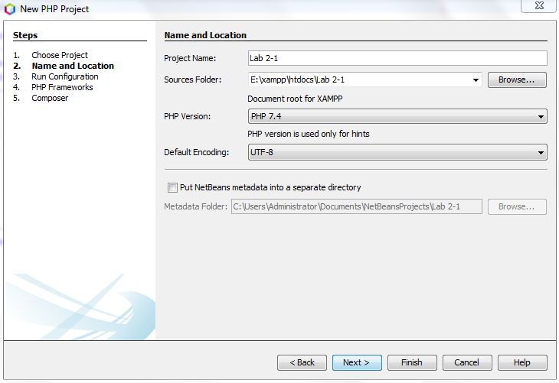

Expression Example

Create a php file named “Expression Example”
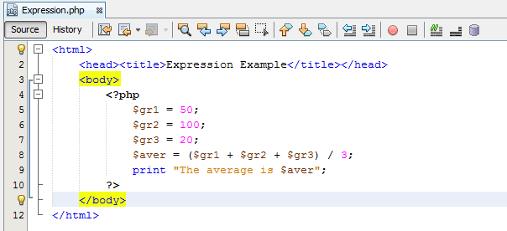

Create a String test
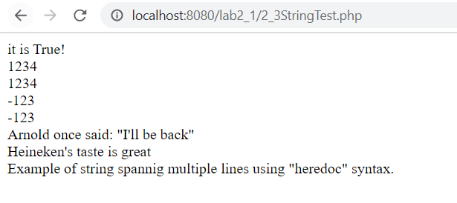

Create a Basic form
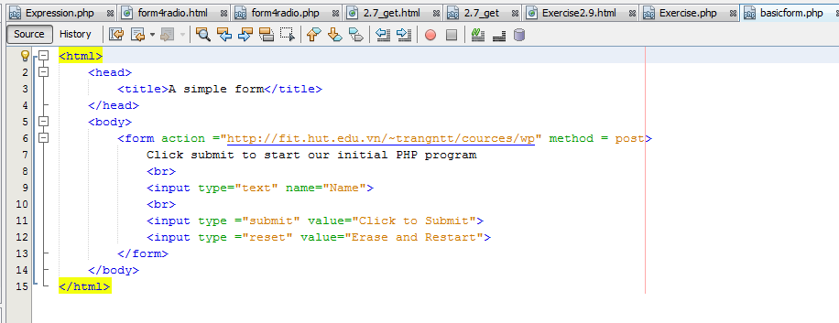

Create a registration form
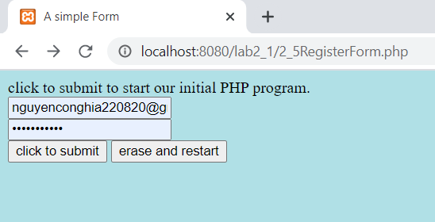

Create a confirm form

Create Form4Radio.html
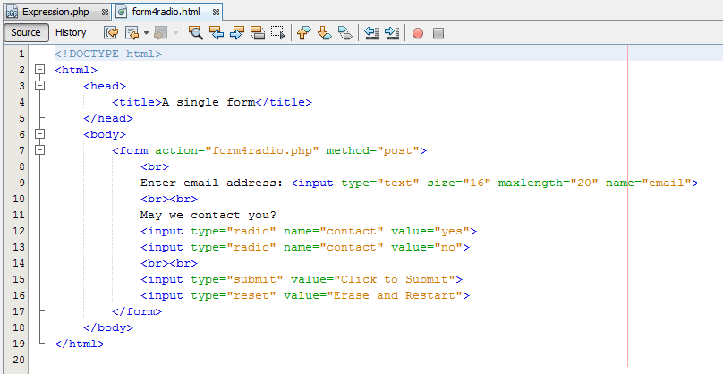

Create Form4Radio.php
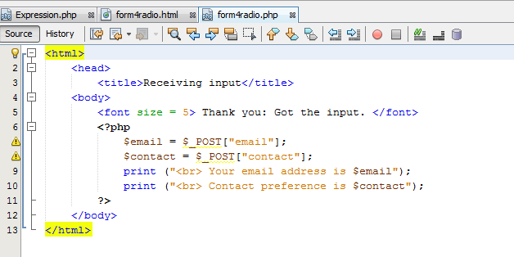

Run the Form4Radio.html

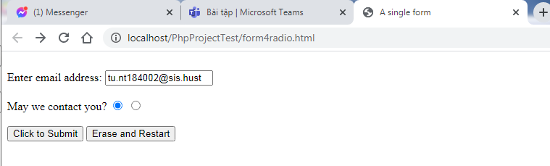
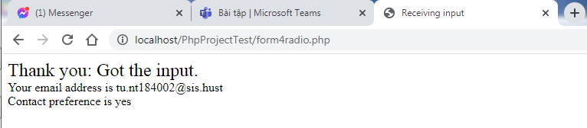

Change to GET method
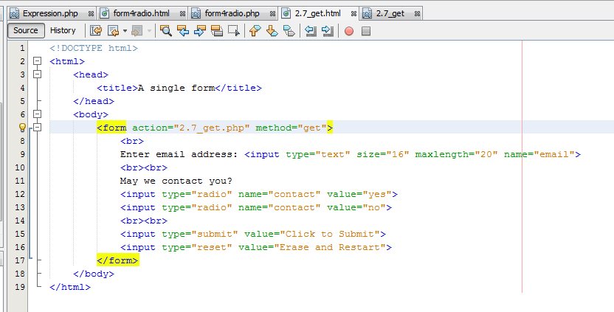
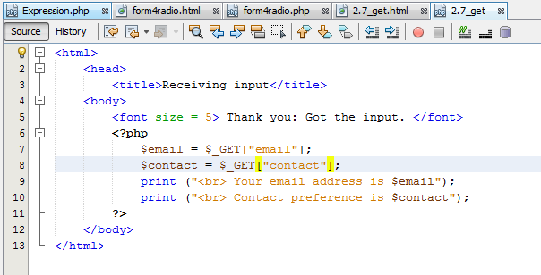
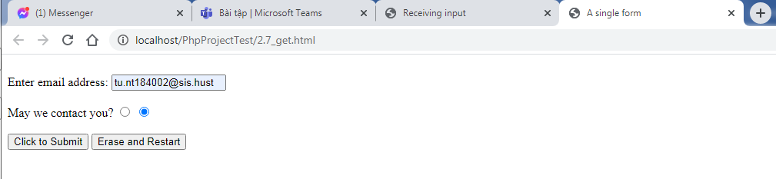

Firefox and Add-ons

Install Firefox & Add-ons
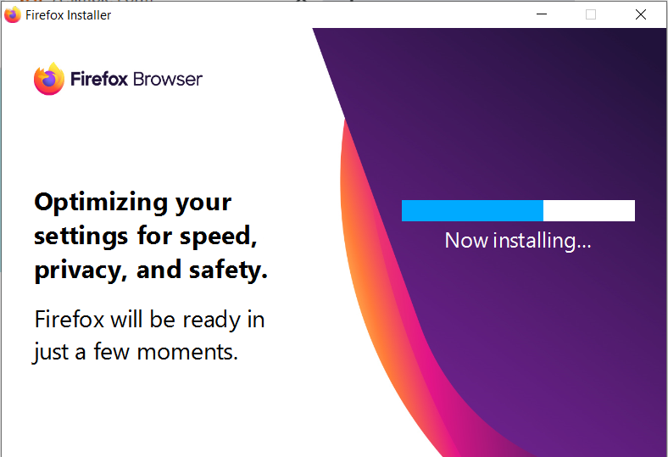
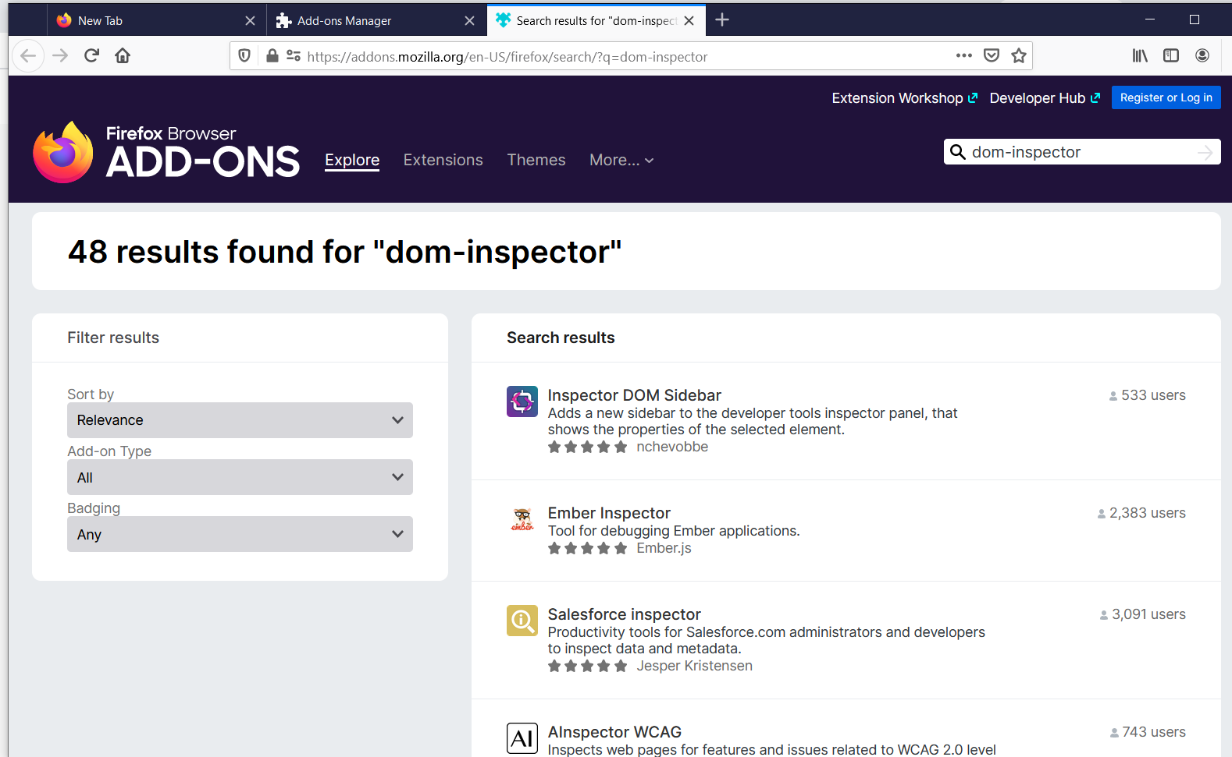

Using DOM Inspector
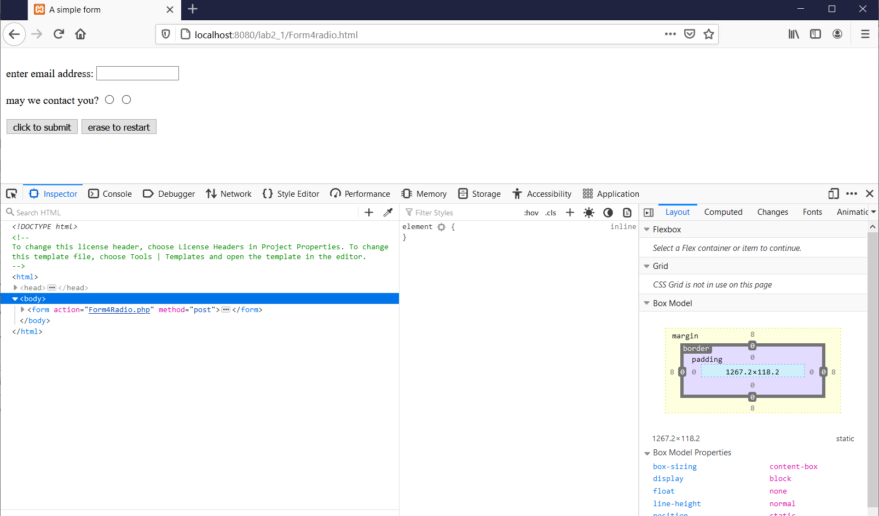

Step 3. Using Firebug
Firebug đã ngừng hoạt động từ năm 2017

Exercise
